Experiment - 2 : Setting Up a Zoho Creator Account and Exploring the Platform Architecture and Interface

Aim:
To create a Zoho Creator account and explore the platform architecture, features, and
user interface for developing low-code applications.

Theory:
Zoho Creator is a cloud-based low-code application development platform that enables users to build custom business applications with minimal coding. It provides a visual development environment where applications can be designed using drag-and-drop components, forms, workflows, reports, and dashboards.

The platform architecture consists of the following components:
- Applications: Containers that hold all forms, reports, workflows, pages, and settings.
- Forms: Used to collect and store user data.
- Reports: Display and manage stored data in various formats such as lists, tables, and calendars.
- Pages: Custom interfaces that combine multiple components into a single view.
- Workflows: Automate tasks using event-based actions and business logic.
- Deluge Script: Zoho Creator's scripting language used to implement advanced functionality and automation.
- Users and Permissions: Control access to applications and define user roles.

The Zoho Creator interface includes the Home Dashboard, Application Builder, Form Designer, Report Builder, Workflow Builder, Navigation Panel, and Settings menu, allowing users to efficiently design, test, and deploy applications.

Procedure:

Open a web browser and navigate to the Zoho Creator website.
Create or access the Zoho Creator account and open the Zoho Creator home dashboard.

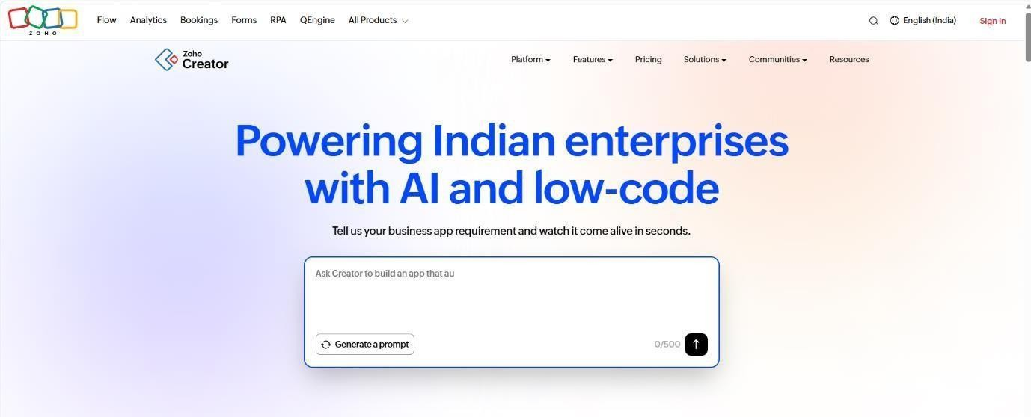

Fig. 2.1: Zoho Creator Home Dashboard

- Create a Zoho account or sign in using existing credentials.
Sign in to Zoho Creator using an existing Zoho account or create a new account if required.
After signing in, the Zoho Creator home page provides access to the applications available to the user.
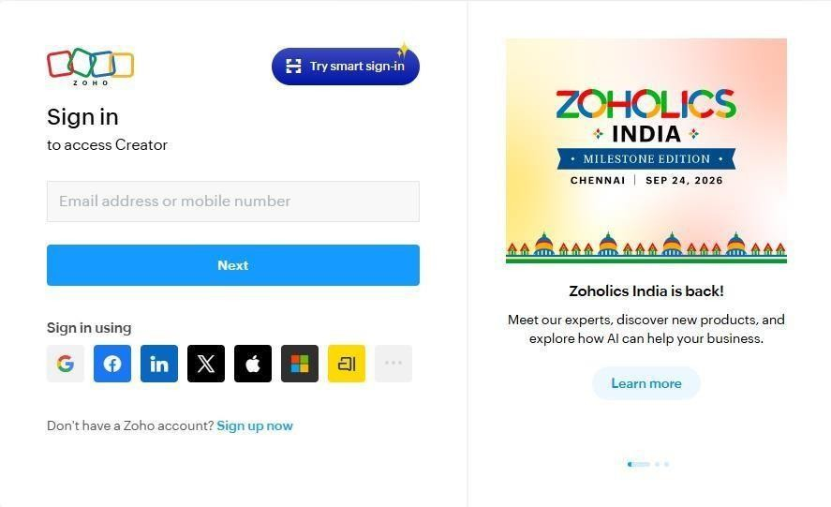

Fig. 2.2: Zoho Creator Account and Application Dashboard

- Access the Zoho Creator dashboard.
The Creator dashboard provides access to existing applications and options for creating new applications. An application can be created from scratch or using a pre-built template.

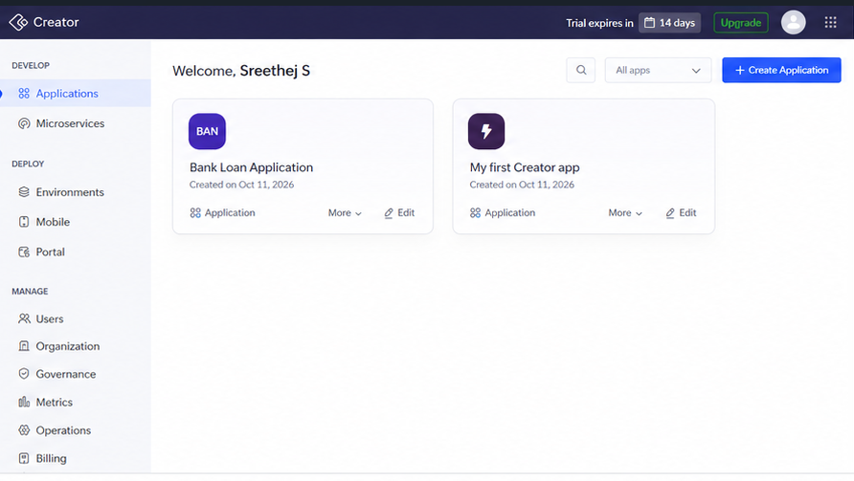

Fig. 2.3: Create Application Interface

- Create a new application using either a blank application or a pre-built template.
Create a simple application for exploring the different components of Zoho Creator.
After creating the application, open the application in Edit Mode. The edit mode is the main development environment where forms, reports, pages, and workflows can be created and modified.
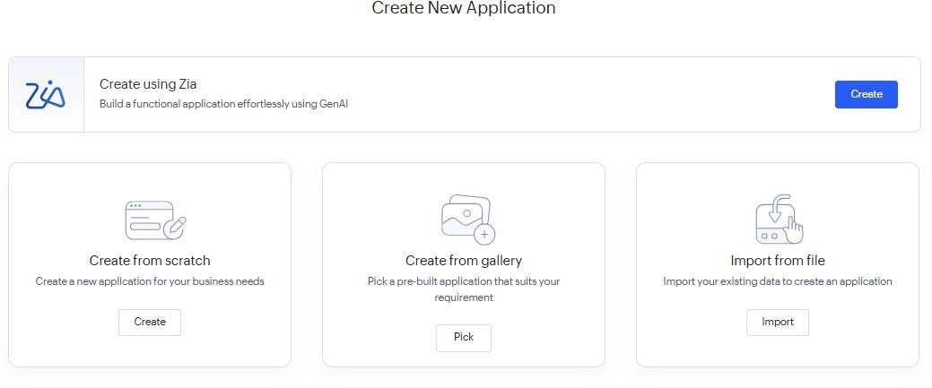

Fig. 2.4: Zoho Creator Application Builder Interface

- Explore the Application Builder interface.
Explore the Application Builder and its navigation options.
The Application Builder provides access to the major components of the application. The + option can be used to add components such as Forms, Reports, Pages, and Workflows.

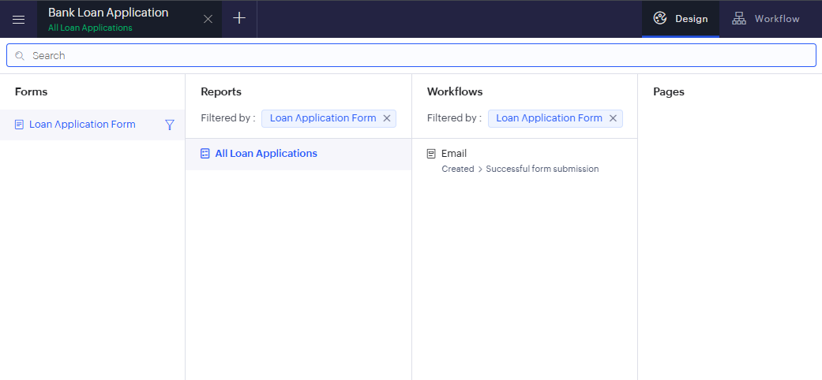

Fig. 2.5: Application Builder Navigation Panel

- Examine the Form Designer and add sample fields such as text, number, date, and email.
Forms provide the interface through which users enter and store structured data. The fields determine the type of information collected from users.
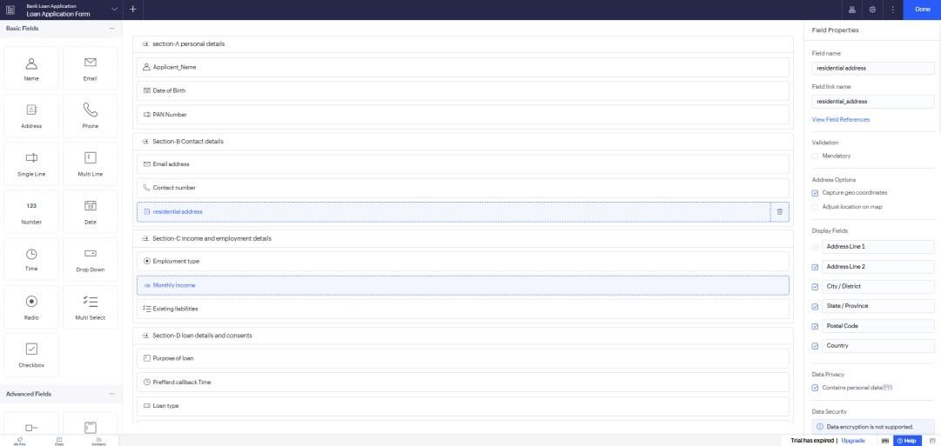

Fig. 2.6: Form Designer with Sample Fields

- Enter sample data into the created form.
Open the form in live/user mode and enter sample information into the fields.

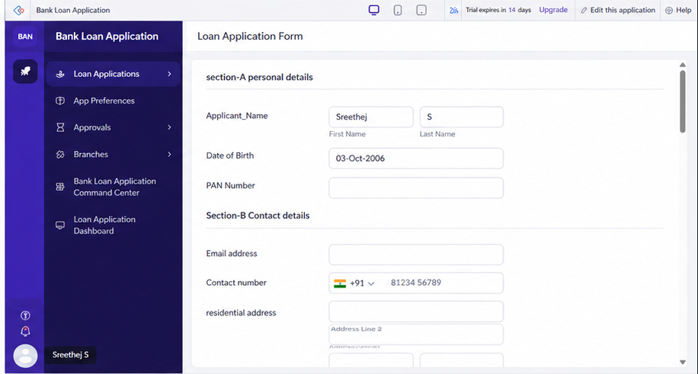

Fig. 2.7: Sample Data Entry Form
This demonstrates the user-facing side of the application. Zoho Creator's live mode allows the application to be viewed and used from an end-user perspective.

Explore the Report Builder to view the generated records.
Submit the sample form and open the generated report.
Reports display the data collected through forms. A standard list/table report is automatically created when a form is created.
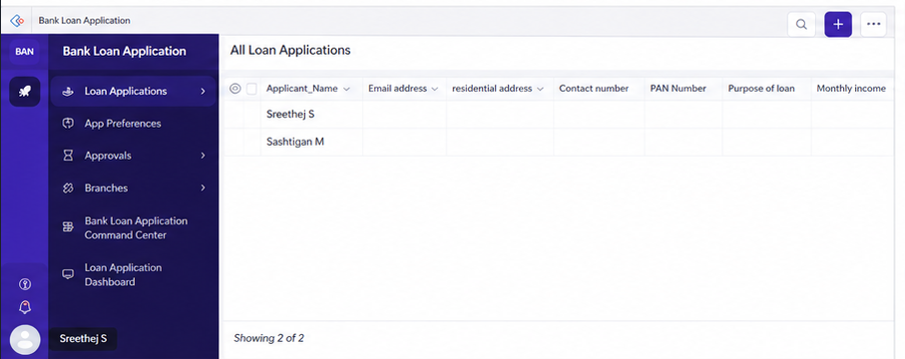

Fig. 2.8: Report Displaying Submitted Records
This demonstrates the relationship:
Form → Data → Report

Navigate through the Workflow section to understand automation features.
Open the Workflow section of the application and explore the available workflow options.
Workflows consist of actions that are executed at specific points to automate routine tasks within an application.

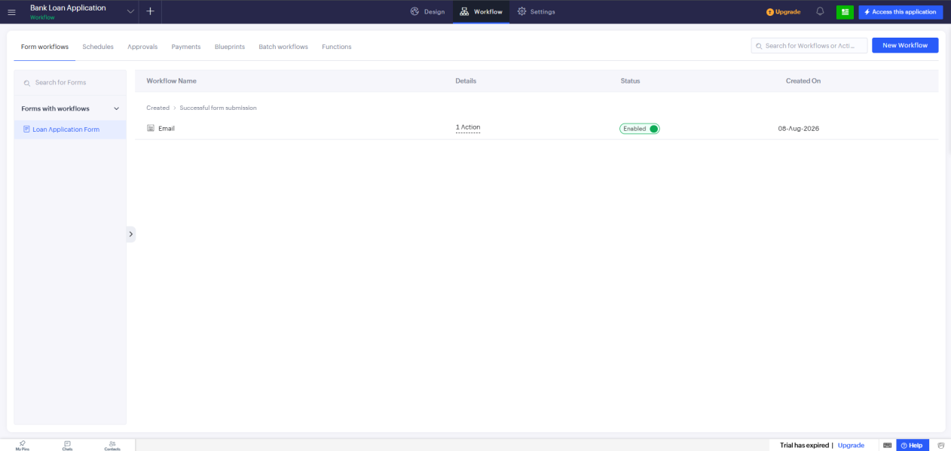

Fig. 2.9: Workflow Builder Interface
A simple workflow may be created if required, but for this experiment, exploring the Workflow Builder is sufficient.

Explore Pages and the Page Builder.
Create or open a Page in the application and explore the Page Builder.
Pages provide customized interfaces where information can be presented using components such as graphs, buttons, panels, forms, reports, and embedded links.

Explore the application navigation menu.
Explore the application's navigation menu and observe how forms, reports, and pages can be organized for easier access.
The app menu provides a visual and logical way to group application components and improve navigation.
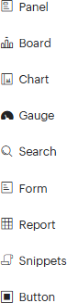

Fig. 2.11: Application Navigation Menu

- Explore Settings, User Management, and Application Permissions.
Navigate to the application settings and explore the available user management and permission options.
Zoho Creator allows application administrators to control access to applications and individual components by assigning appropriate permissions to users.
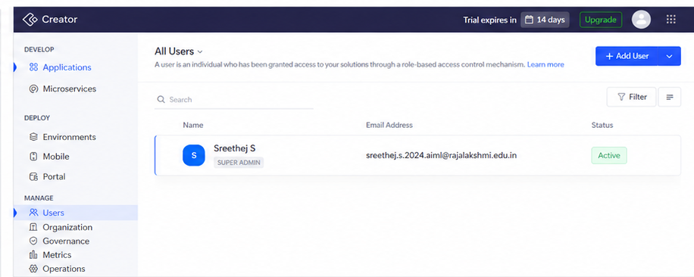

Fig. 2.12: Application Settings and User Permissions

- Explore the Deluge Script environment.
Explore the scripting options available in Zoho Creator to understand how advanced functionality and automation can be implemented using Deluge Script.
Deluge is integrated into Creator for implementing functions and advanced application logic.

Observe the overall platform architecture and note the functions of each component.
Finally, observe how the different components work together to form a complete application. The basic architecture explored during the experiment can be represented as:

Application
→ Forms – Collect and store data

→ Reports – Display and analyze stored data
→ Pages – Provide customized user interfaces
→ Workflows – Automate tasks and business processes
→ Deluge Script – Implement advanced logic and functionality
→ Users & Permissions – Control access to the application

Result:
A Zoho Creator account was successfully created, and the platform architecture and user interface were explored. The experiment demonstrated that Zoho Creator provides an intuitive low-code environment with tools such as forms, reports, workflows, pages, and dashboards, enabling rapid application development with minimal programming effort.

